Frequently asked questions
What happens when my manuscript has been accepted?
When you are notified that your manuscript has been accepted for publication, you will be asked to sign an online licence based on your route to publication (see instructions below). Once completed, your work will enter the production process.
How do I submit revisions to my manuscript?
If your manuscript requires revisions after it has been through the peer review process, you will need to resubmit it in ScholarOne. Changes cannot be made to your accepted paper.
How do I know if my manuscript has been accepted?
If your work is accepted for publication, you will receive a notification email from ScholarOne.
How do I publish my work open access?
Gold open access
Once your work has been accepted, you can select to publish your work through the open access route.
- If you are eligible for a prepaid open access publishing voucher based on your affiliation, it will be applied automatically
- If you are eligible for a waiver based on the country you are based in, it will be applied automatically
- If you are not eligible for a waiver or prepaid open access publishing voucher, you will be required to pay an article processing charge (APC)
Once you have confirmed your open access route to publication, you will need to sign a Creative Commons Attribution 4.0 International (CC BY) licence.
Green open access/self-archiving
Our green open access route offers all Emerald journal authors the option to make their research immediately and openly available upon official publication, free from payment. You may deposit your author accepted manuscript at any point, but it must not be made publicly accessible until official publication. Find out more on our open research policies page.
Am I eligible for a prepaid open access publishing voucher?
We work closely with libraries and national consortia to support their goals and requirements for open access research output. A number of organisations have established partnerships with us to cover the cost of an agreed number of gold open access articles or arranged a discount for their regions. You can check your eligibility on our open access publishing agreements page.
Am I eligible for a waiver?
Corresponding authors based in countries classified by the World Bank as ‘low’ or ‘lower – middle’ income are eligible for a full or 50% waiver to publish in fully open access Emerald journals. For further details, please see our APC waiver policy. Waivers are only available on our Gold OA journals and not on every Emerald journal.
How do I pay for an article processing charge (APC)?
If you are required to pay an article processing charge for publishing your work through the open access route, you can do this in two ways.
- You can pay securely online using a credit or debit card
- Alternatively, you can pay through an invoice which can be issued to you or sent directly to the payer to be paid by the funding source.
Please be aware that your work will not enter the production process until the APC has been paid.
If you have any payment queries, please contact subscriptions@emerald.com.
How do I access Emerald Submit?
The Emerald Submit website is accessible via the URL https://submit.emerald.com.
Emerald Submit uses the standard Emerald Insight profile in order to access the site. If you already have an Emerald profile account, please login using this. If you have forgotten your password you will be able to reset it from our login screen:
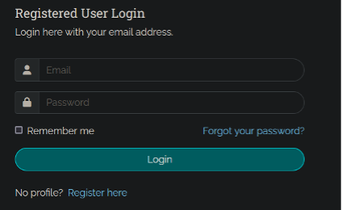
If you do not have an account yet, please register here or follow the link on the login page.
IMPORTANT NOTE: The system takes your submission and the email address you used for the submission on ScholarOne in order to populate your author dashboard. Therefore your Emerald Submit account should ONLY be created using the email address with which you submitted your paper in ScholarOne. If your email addresses do not match you will be unable to use Emerald Submit.
Access our detailed login guide here: https://submit.emerald.com/files/login-guide.pdf
How does Emerald Submit work?
Emerald Submit is an easy-to-use platform for choosing your publication route and signing your copyright licence.
Here is how it works:
- Once you have received an email from us to inform you that you have a licence to sign, visit the website https://submit.emerald.com and login using your Emerald profile.
- You will see a red circle on the “Accepted” tab within your author dashboard:
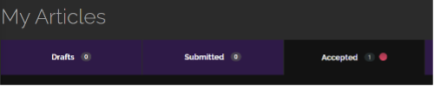
- You can then click through to choose your publication route and sign the relevant publishing licence online.
- Once this is done the system will tell you that your actions are complete and your paper is on its way to the production team:
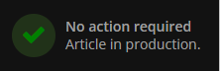
If you are eligible for a prepaid open access publishing voucher or a waiver based on your affiliation, this will be automatically applied when your manuscript is accepted.
If you are publishing your work through the open access route and are not eligible for a prepaid open access publishing voucher, you will be directed to the payment portal.
How do I change my name and/or email address?
Within your profile you can access buttons to edit your details as required:
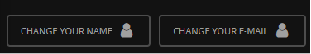
At the top left of every screen you can find the profile and logout links:
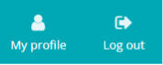
How do I update my author affiliation?
Within your profile, click on the update affiliation button:
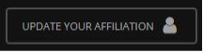
You will then be taken to a page where you can enter your details:
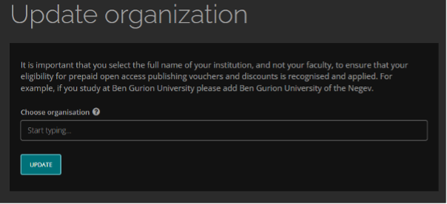
What happens when I have signed my licence?
When you have chosen your publication route and successfully signed your licence in the Submit author dashboard, you will see a note on screen informing you that your article is now entering the production process. At this point all steps are now completed within Emerald Submit.
How long will it take to receive my proofs?
Your article proofs will usually arrive within 10-14 working days of signing your licence.
How do I correct mistakes with author names or change the author order on my paper?
Corrections like this can be made without resubmitting your paper. You can action them when you receive your proofs. Look out for an email from us informing you that your proofs are ready to view online.
Have any more questions or require assistance?
Email us at submitsupport@emerald.com

